What is a DataFrame?
A DataFrame is a two-dimensional table of data in Python.
It looks like an Excel sheet or database table with rows and columns.
Example:
Name | Age | City
Rohan | 21 | Ahmedabad
Amit | 22 | Surat
Neha | 20 | Vadodara

So basically:
DataFrame = Table of data (rows + columns)

>> Why Do We Use a DataFrame?
We use DataFrames to store, organize, and analyze data easily.
Main reasons:

1. To handle large datasets
A DataFrame can store thousands or millions of rows of data.
Example:
- Student records
- Sales data
- Weather data
- Survey results

2. Easy Data Analysis
We can easily perform operations like:
- filtering data
- sorting
- grouping
- calculating average, sum, etc.
Example:
df["Age"].mean()
This calculates average age.

3. Easy Data Cleaning
In real datasets there are:
- missing values
- duplicate rows
- incorrect data
DataFrames allow us to clean the data easily.
Example:
df.drop_duplicates()

4. Easy Data Import and Export
DataFrames can read many file formats like:
- CSV
- Excel
- JSON
- SQL databases
Example:
pd.read_csv("data.csv")

5. Used in Data Science and Machine Learning
DataFrames are heavily used in:
- Data Analysis
- Data Science
- Machine Learning
Why We Use Different Methods to Create DataFrames
Method | When we use it
Dictionary of Lists | When data is column-wise
List of Lists | When data is row-wise
List of Dictionaries | When each row is stored as a dictionary
Dictionary of Series | When combining multiple Series
NumPy Array | When working with numerical arrays from NumPy
CSV File | When loading data from files
Empty DataFrame | When we want to create structure first and add data later
1️. Create DataFrame using Dictionary of Lists
A dictionary of lists means each key becomes a column and the list becomes column values.
Example: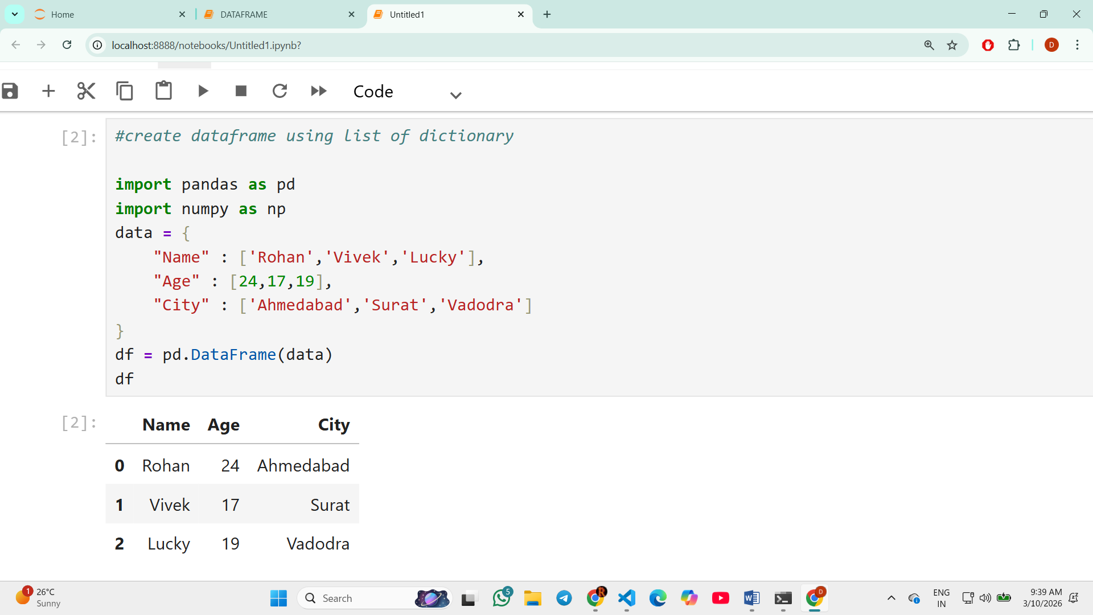

2.Create DataFrame using List of Lists
Each inner list represents a row.
Example: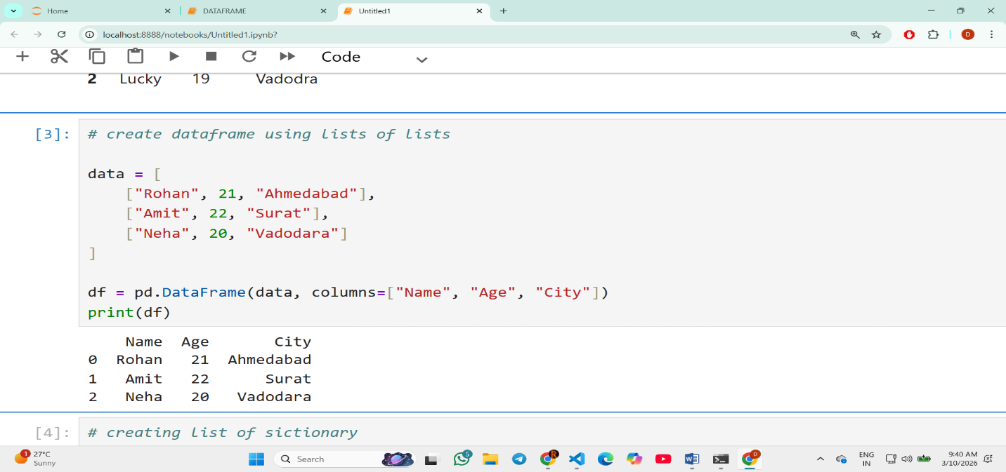
3. Create DataFrame using list of dictionary
Each Dictionary represent rows
Example: 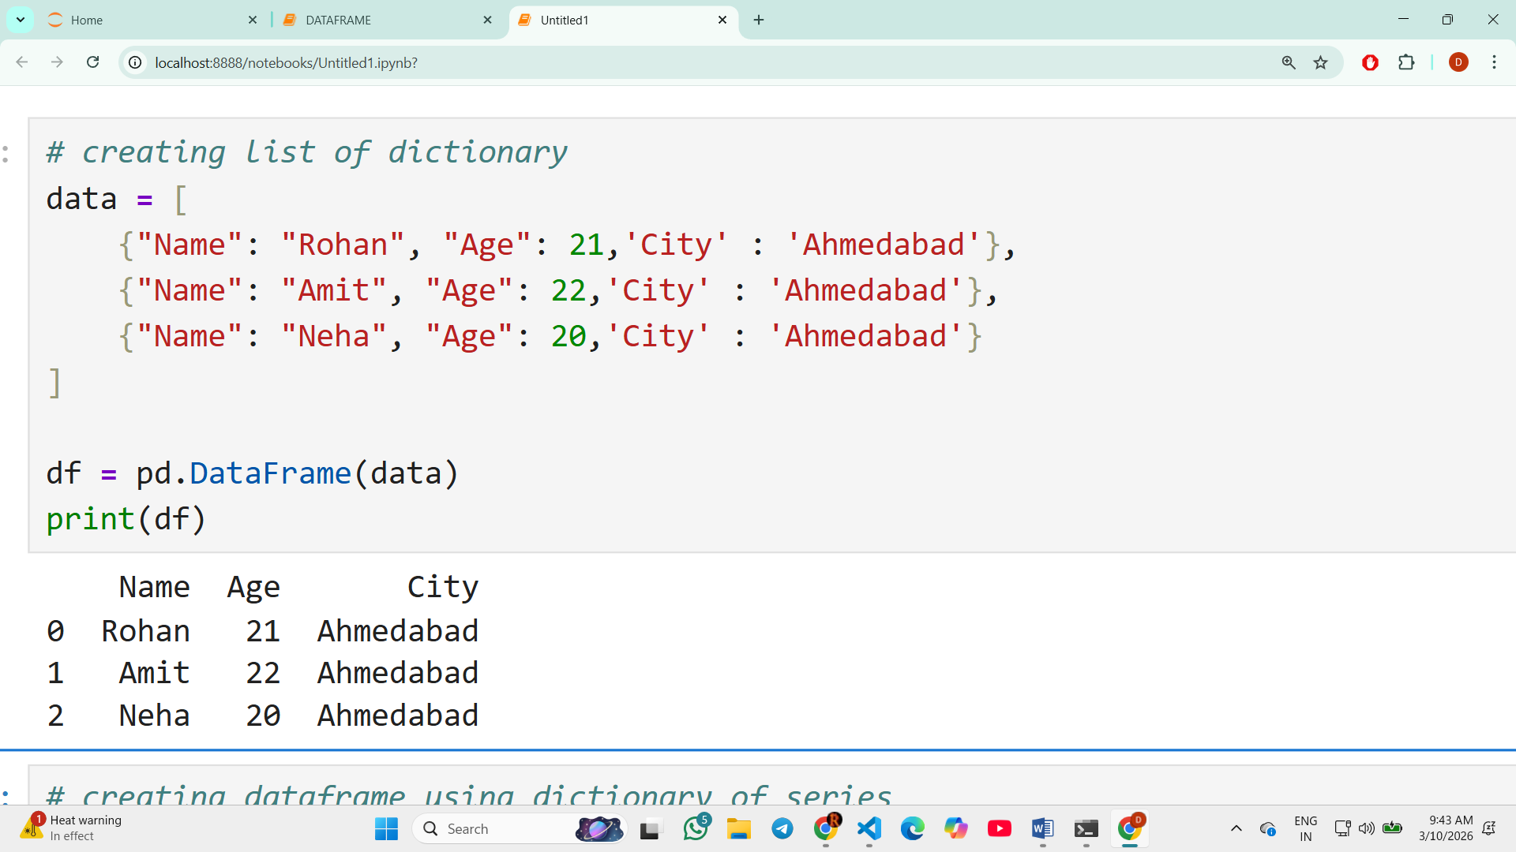
4. Create DataFrame using dictionary of series
A dictionary of lists means each key becomes a column and the list becomes column values.
Example: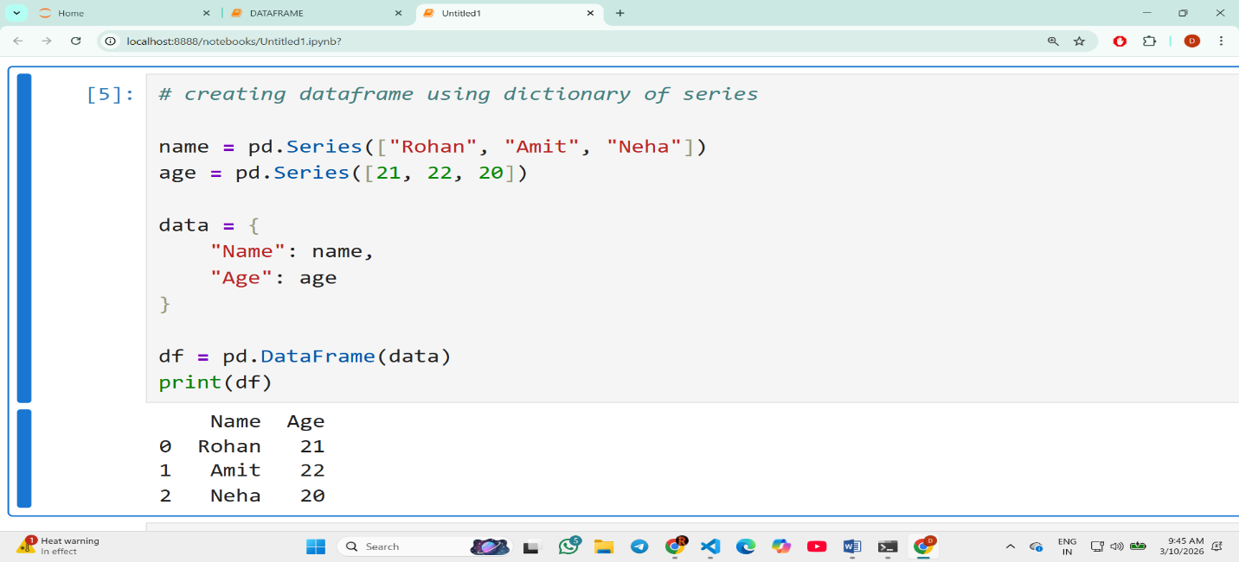
5. Creating DataFrame using np array
Here we’ll be seeing that how we use numpy library.
Example: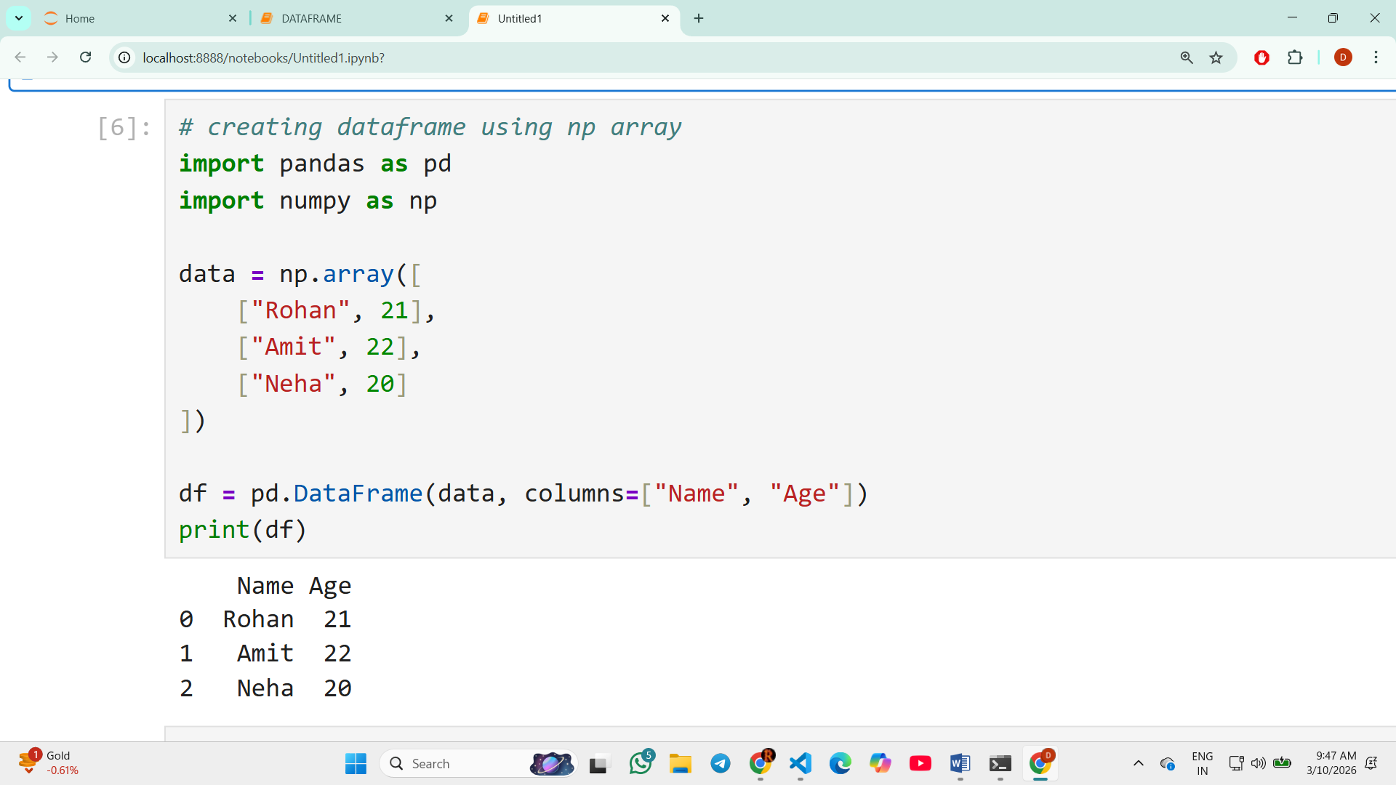
6. Creating Empty DataFrame
If we just want to create a DataFrame and want to fill out the values later than we will be using this.
Example: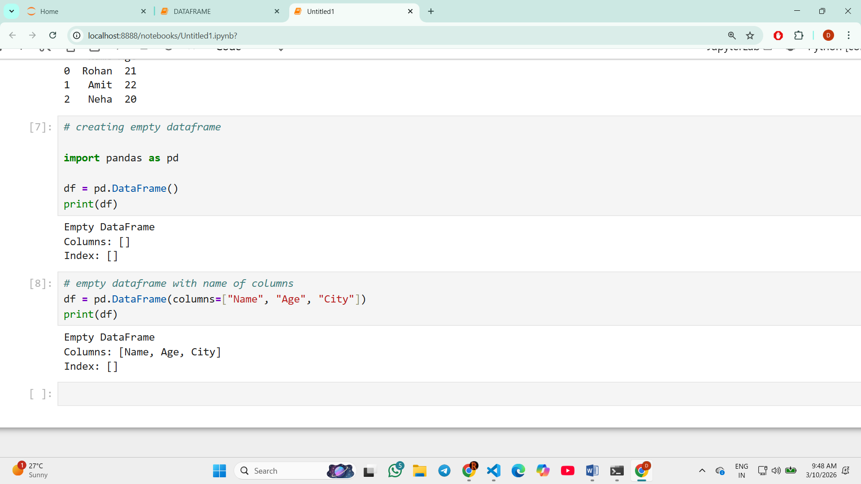
>>> MOST OF THE TIME WE WILL BE USING THIS SYNTAX ONLY AS PER GIVEN BELOW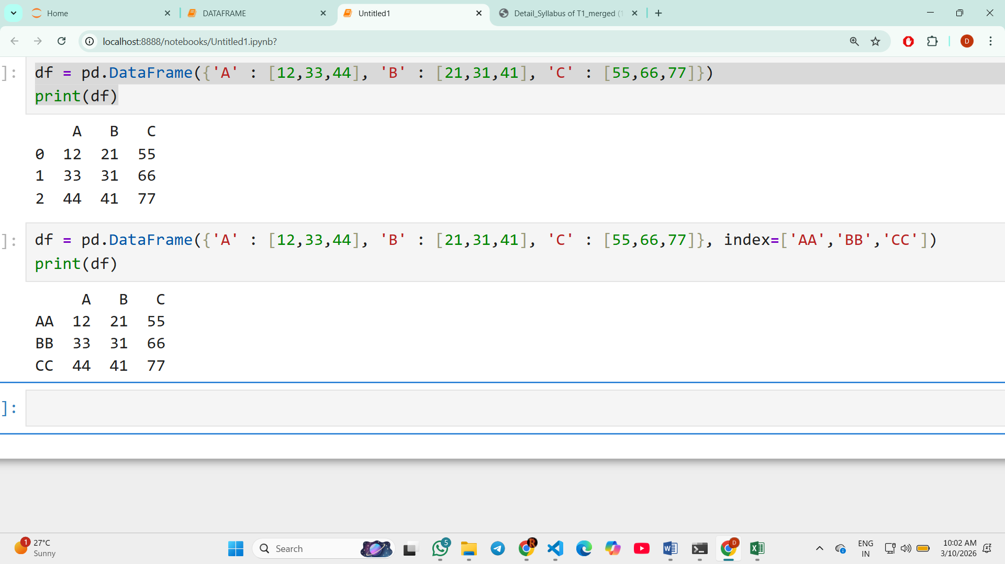

=> set_index(Keys, drop=True, inplace=True)

Purpose
set_index() is used to convert a column into the index (row label) of the DataFrame.

Syntax

df.set_index(keys, drop=True, inplace=True)
Parameter | Meaning
keys | Column name that will become the index
drop=True | Removes that column from the DataFrame
inplace=True | Makes the change in the original DataFrame
Example:
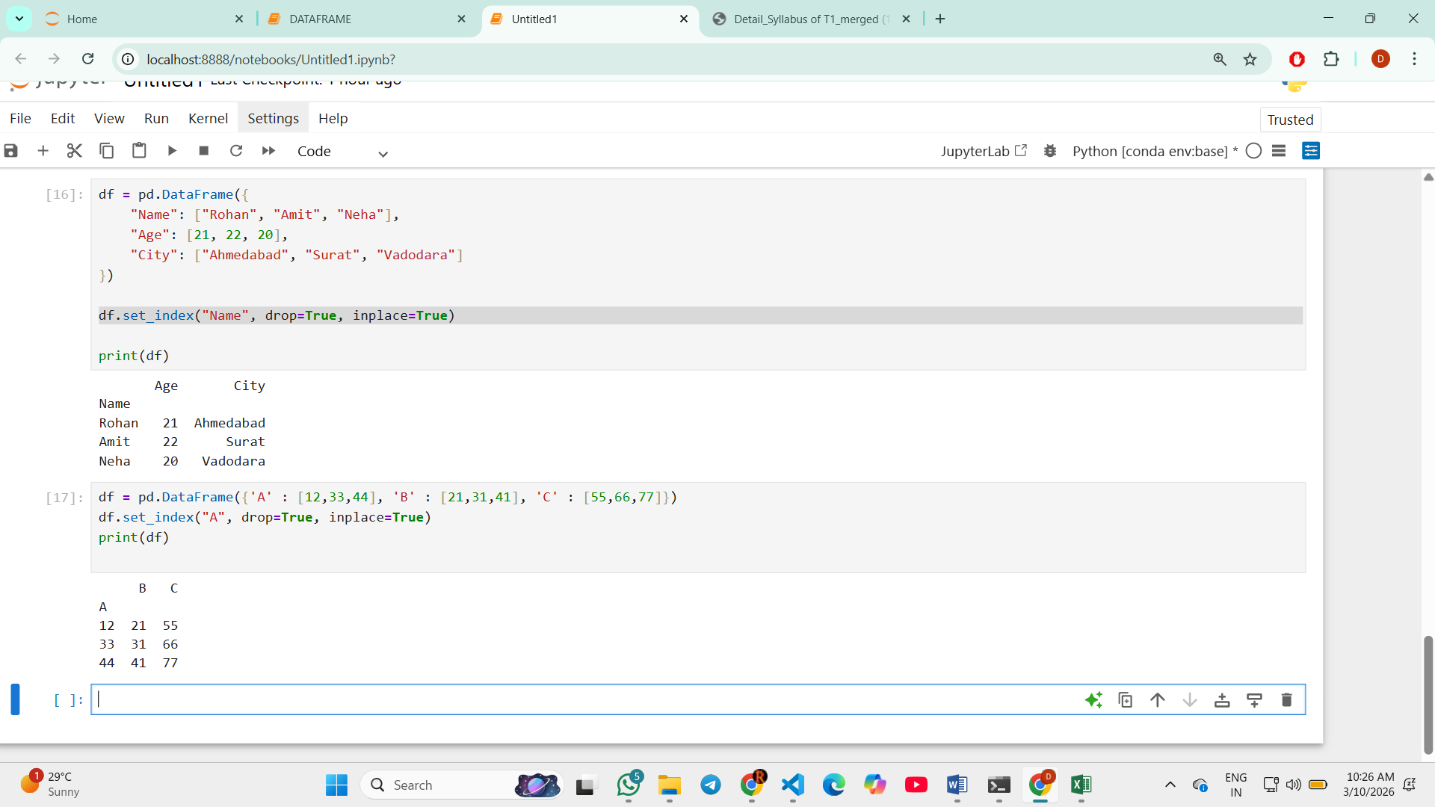
=>> Reset Index:: Gives the original indexes 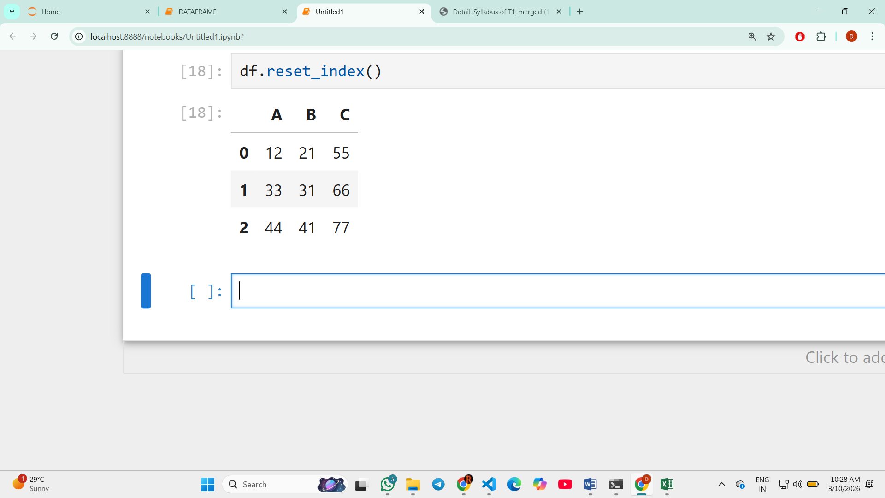
ATTRIBUTES OF DATAFRAME
Attribute | Purpose
shape | Number of rows and columns
size | Total elements in DataFrame
ndim | Number of dimensions
columns | Column names
index | Row labels
dtypes | Data type of each column
values | Data as NumPy array
Index:
- loc(label based index)
In pandas, loc is used to access or select data from a DataFrame using row and column labels (names).

Syntax
df.loc[row_label, column_label]

Key Points
- Works with labels (names), not positions.
- Used to select rows, columns, or specific values.
- Can also be used to modify values.
Example: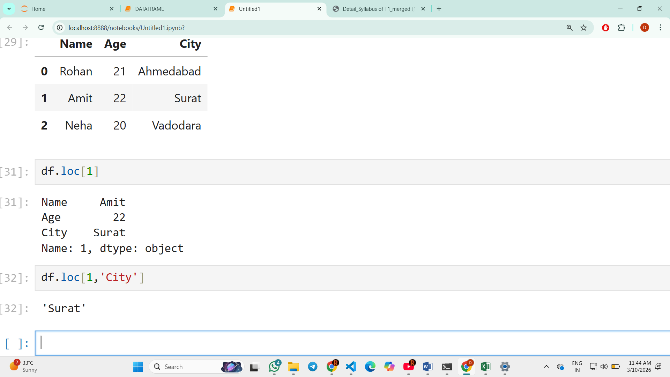
- Iloc(position based index)
In pandas, iloc is used to select or access data using numerical positions (index numbers).

Syntax
df.iloc[row_position, column_position]

Key Points
- Works with integer positions (0,1,2...).
- Used to select rows, columns, or specific values by position.
- Mainly used when we do not know column names.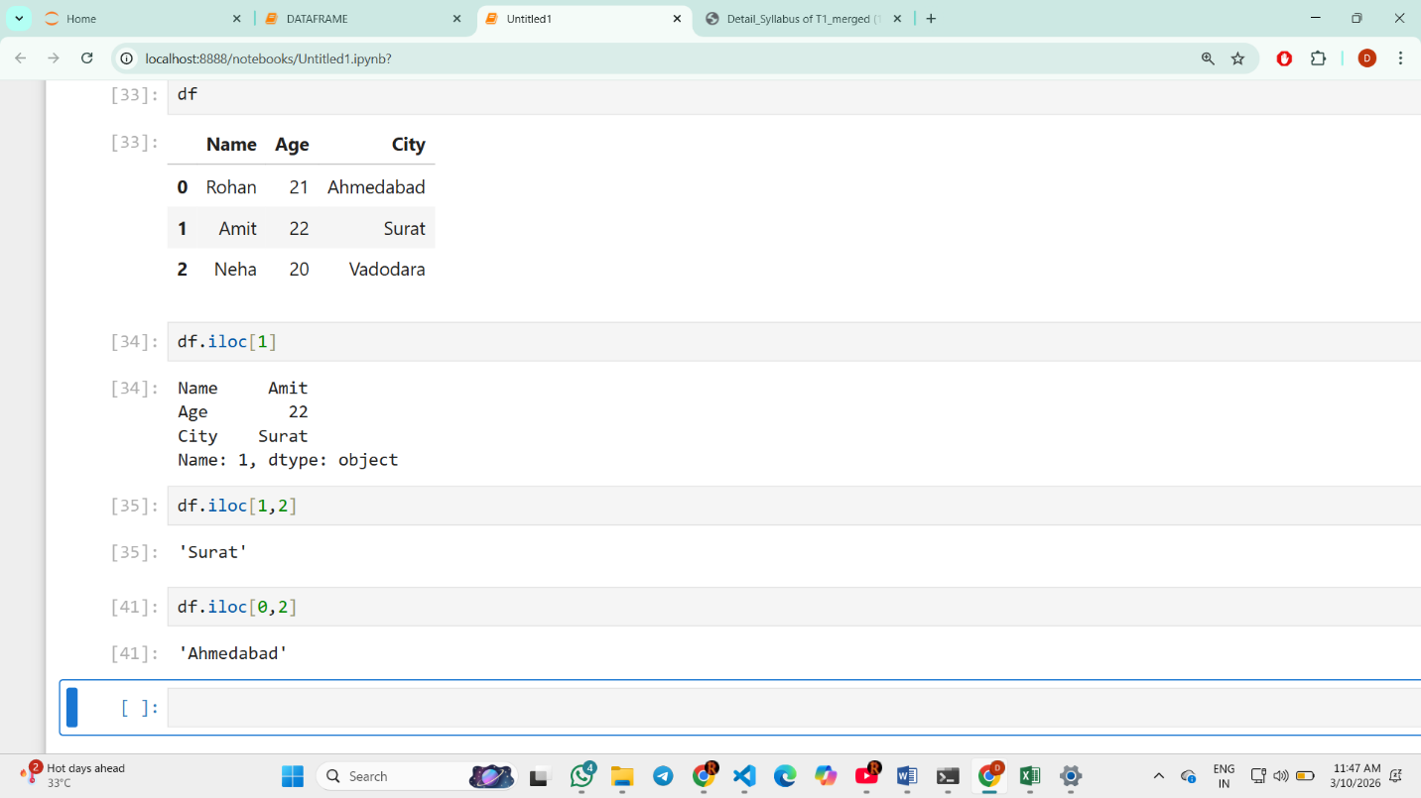

- Slicing(selecting specific rows and columns)
Generally done by using loc and iloc
Syntax:
df.loc[start_label:end_label]
Example: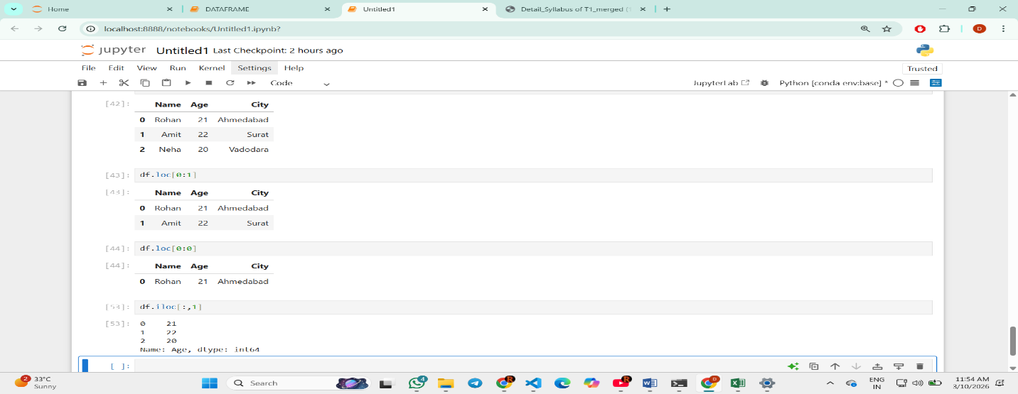
=>> Add new row in DataFrame+
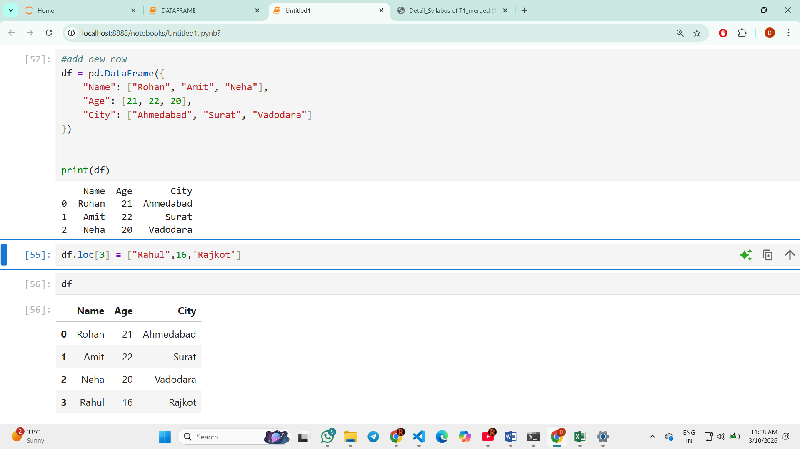
=>> Add new column in DataFrame